14

FIRMS IN
COMPETITIVE MARKETS

WHAT’S NEW IN THE SEVENTH EDITION:

There are no major changes to this chapter.

LEARNING OBJECTIVES:

By the end of this chapter, students should understand:

➢ what characteristics make a market competitive.
➢ how competitive firms decide how much output to produce.
➢ how competitive firms decide when to shut down production temporarily.
➢ how competitive firms decide whether to exit or enter a market.
➢ how firm behavior determines a market’s short-run and long-run supply curves.

CONTEXT AND PURPOSE:

Chapter 14 is the second chapter in a five-chapter sequence dealing with firm behavior and the organization of industry. Chapter 13 developed the cost curves on which firm behavior is based. These cost curves are employed in Chapter 14 to show how a competitive firm responds to changes in market conditions. Chapters 15 through 17 will employ these cost curves to see how firms with market power (monopolistic, monopolistically competitive, and oligopolistic firms) respond to changes in market conditions. The purpose of Chapter 14 is to examine the behavior of competitive firms—firms that do not have market power. The cost curves developed in the previous chapter shed light on the decisions that lie behind the supply curve in a competitive market.

KEY POINTS:

• Because a competitive firm is a price taker, its revenue is proportional to the amount of output it produces. The price of the good equals both the firm’s average revenue and its marginal revenue.

• To maximize profit, a firm chooses a quantity of output such that marginal revenue equals marginal cost. Because marginal revenue for a competitive firm equals the market price, the firm chooses quantity so that price equals marginal cost. Thus, the firm’s marginal-cost curve is its supply curve.
• In the short run when a firm cannot recover its fixed costs, the firm will choose to shut down temporarily if the price of the good is less than average variable cost. In the long run when the firm can recover both fixed and variable costs, it will choose to exit if the price is less than average total cost.

• In a market with free entry and exit, profit is driven to zero in the long run. In this long-run equilibrium, all firms produce at the efficient scale, price equals the minimum of average total cost, and the number of firms adjusts to satisfy the quantity demanded at this price.

• Changes in demand have different effects over different time horizons. In the short run, an increase in demand raises prices and leads to profits, and a decrease in demand lowers prices and leads to losses. But if firms can freely enter and exit the market, then in the long run the number of firms adjusts to drive the market back to the zero-profit equilibrium.

CHAPTER OUTLINE:

I. What Is a Competitive Market?

A. The Meaning of Competition

Remember that students have a difficult time understanding what a competitive market is. The use of the word “competition” in economics is much different from that in sports. This will lead students to often forget that these firms are generally unconcerned with the actions of their rivals.

1. Definition of competitive market: a market with many buyers and sellers trading identical products so that each buyer and seller is a price taker.

2. There are three characteristics of a competitive market (sometimes called a perfectly competitive market).

a. There are many buyers and sellers.

b. The goods offered by the sellers are largely the same.

c. Firms can freely enter or exit the market.

B. The Revenue of a Competitive Firm
Table 1

To help students understand price-taking behavior, use the example of common stock. Have your students assume that they inherited 100 shares of stock in a well-known company. Point out that these 100 shares may seem like a lot, but it is a very small proportion of the total number of shares outstanding. If the student wanted to know the value of a share, it could be obtained from a broker. At this market-determined price, the student could sell as few or as many shares as he or she wishes. At a price above this, no one would be willing to buy any. There is also no reason to charge a price below the current market price, because the student can sell any number of shares that he or she wishes at the current price.
1. Total revenue from the sale of output is equal to price times quantity.

Make sure that students realize that firms in perfect competition can only change their level of total revenue by varying their level of output because they have no ability to change the price.

2. Definition of average revenue: total revenue divided by the quantity sold.
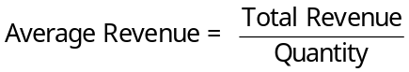

3. Definition of marginal revenue: the change in total revenue from an additional unit sold.
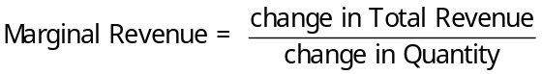

You may want to make it clear that, by definition, average revenue is always equal to price. But marginal revenue is equal to price only for firms that operate in perfectly competitive markets.

II. Profit Maximization and the Competitive Firm's Supply Curve

A. A Simple Example of Profit Maximization: The Vaca Family Dairy Farm
Table 2

Q | Total Revenue | Total Cost | Profit | Marginal Revenue | Marginal Cost | Change in Profit
0 | $0 | $3 | $-3 | ---- | ---- | ----
1 | 6 | 5 | 1 | $6 | $2 | $4
2 | 12 | 8 | 4 | 6 | 3 | 3
3 | 18 | 12 | 6 | 6 | 4 | 2
4 | 24 | 17 | 7 | 6 | 5 | 1
5 | 30 | 23 | 7 | 6 | 6 | 0
6 | 36 | 30 | 6 | 6 | 7 | -1
7 | 42 | 38 | 4 | 6 | 8 | -2
8 | 48 | 47 | 1 | 6 | 9 | -3

1. In this example, profit is maximized if the farm produces four or five gallons of milk (see the fourth column).

2. The profit-maximizing quantity can also be found by comparing marginal revenue and marginal cost.

a. As long as marginal revenue exceeds marginal cost, increasing output will raise profit.

b. If marginal revenue is less than marginal cost, the firm can increase profit by decreasing output.

c. Profit-maximization occurs where marginal revenue is equal to marginal cost.
ALTERNATIVE CLASSROOM EXAMPLE:
Paulo’s Ping Pong Balls is a firm that operates in a competitive market. The ping pong balls sell for $3 per package. Fill in the following table with the class's help and discuss the profit-maximizing level of output:

Output | Price | Total Revenue | Total Cost | Profit | Marginal Revenue | Marginal Cost
0 | $3 | $0.00 | $1.50 | $-1.50 | ---- | ----
1 | 3 | 3.00 | 2.00 | 1.00 | $3 | $0.50
2 | 3 | 6.00 | 3.00 | 3.00 | 3 | 1.00
3 | 3 | 9.00 | 4.50 | 4.50 | 3 | 1.50
4 | 3 | 12.00 | 6.50 | 5.50 | 3 | 2.00
5 | 3 | 15.00 | 9.00 | 6.00 | 3 | 2.50
6 | 3 | 18.00 | 12.00 | 6.00 | 3 | 3.00
7 | 3 | 21.00 | 15.50 | 5.50 | 3 | 3.50
8 | 3 | 24.00 | 19.50 | 4.50 | 3 | 4.00
9 | 3 | 27.00 | 24.00 | 3.00 | 3 | 4.50

B. The Marginal-Cost Curve and the Firm's Supply Decision

1. Cost curves have special features that are important for our analysis.

a. The marginal-cost curve is upward sloping.

b. The average-total-cost curve is U-shaped.
c. The marginal-cost curve crosses the average-total-cost curve at the minimum of average total cost.
The graphs in this chapter often confuse students because they contain many different curves at the same time. Thus, the first time you draw the profit-maximizing decision of the firm, use only the marginal cost curve and the marginal revenue line. Then, after students feel comfortable with this, add average total cost (to teach students how to measure profit or loss). Last, add average variable cost to teach students about the short-run shutdown decision of a firm earning an economic loss. Point out that each of the short-run cost curves tells a different part of the story.
2. Marginal and average revenue can be shown by a horizontal line at the market price.

3. To find the profit-maximizing level of output, we can follow the same rules that we discussed above.
Figure 1
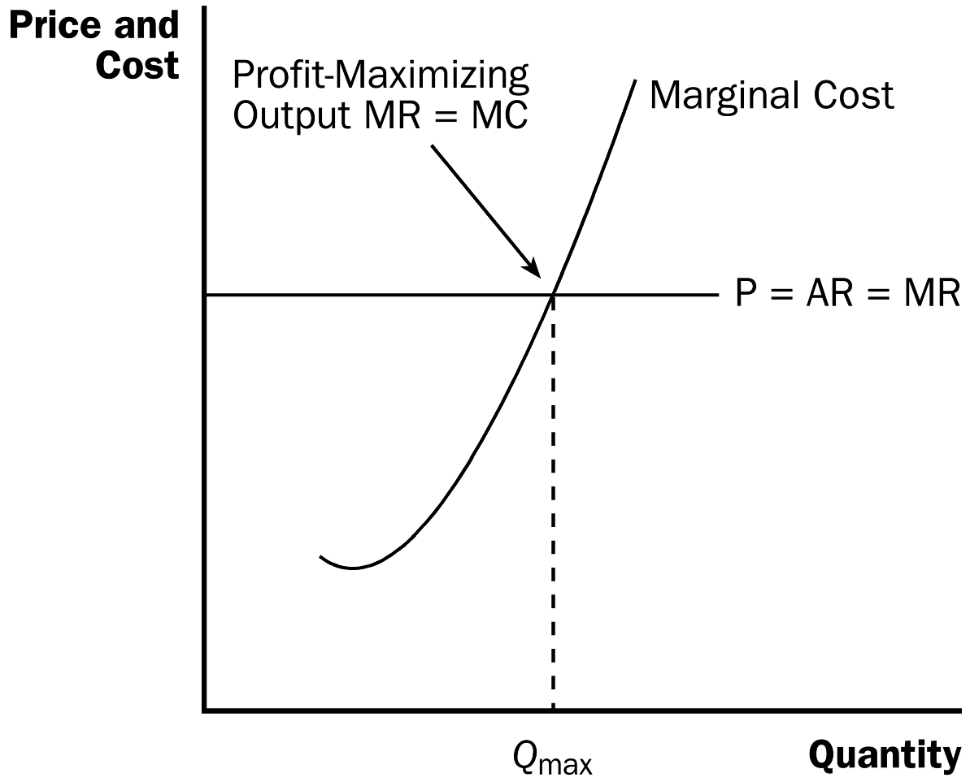

a. If marginal revenue is greater than the marginal cost, the firm should increase its output.

b. If marginal cost is greater than marginal revenue, the firm should decrease its output.

c. At the profit-maximizing level of output, marginal revenue and marginal cost are exactly equal.

4. These rules apply not only to competitive firms, but to firms with market power as well.

Activity 1—A Profitable Opportunity?

Type: In-class assignment
Topics: Profit maximization
Materials needed: None
Time: 15 minutes
Class limitations: Works in any size class

Purpose
This exercise reinforces the importance of marginal cost in decision-making. It shows average costs can be misleading.

Instructions
Tell the class, “As a recent graduate of this college you have landed a job in production management for Universal Clones, Inc. You are responsible for the entire company on weekends.”
“Your costs are shown below.”

Quantity Average Total Cost
500 200
501 201

Your current level of production is 500 units. All 500 units have been ordered by your regular customers.

“The phone rings. It’s a new customer who wants to buy one unit of your product. This means you would have to increase production to 501 units. Your new customer offers you $450 to produce the extra unit.”
a. Should you accept this offer?
b. What is the net change in the firm’s profit?

Common Answers and Points for Discussion
Most students will answer “yes.” Selling something for $450 when the average cost of production is $201 seems like good business. They are wrong.

The relevant comparison is marginal cost to marginal revenue. Marginal cost can be easily calculated as the change in total costs.

Quantity Average Total Cost Total Cost = Q × ATC
500 200 100,000
501 201 100,701

$100,701 – $100,000 = $701

Marginal cost in this example is $701. This is much higher than the marginal revenue of $450. The offer should not be accepted. It would result in a $251 loss.

Figure 2

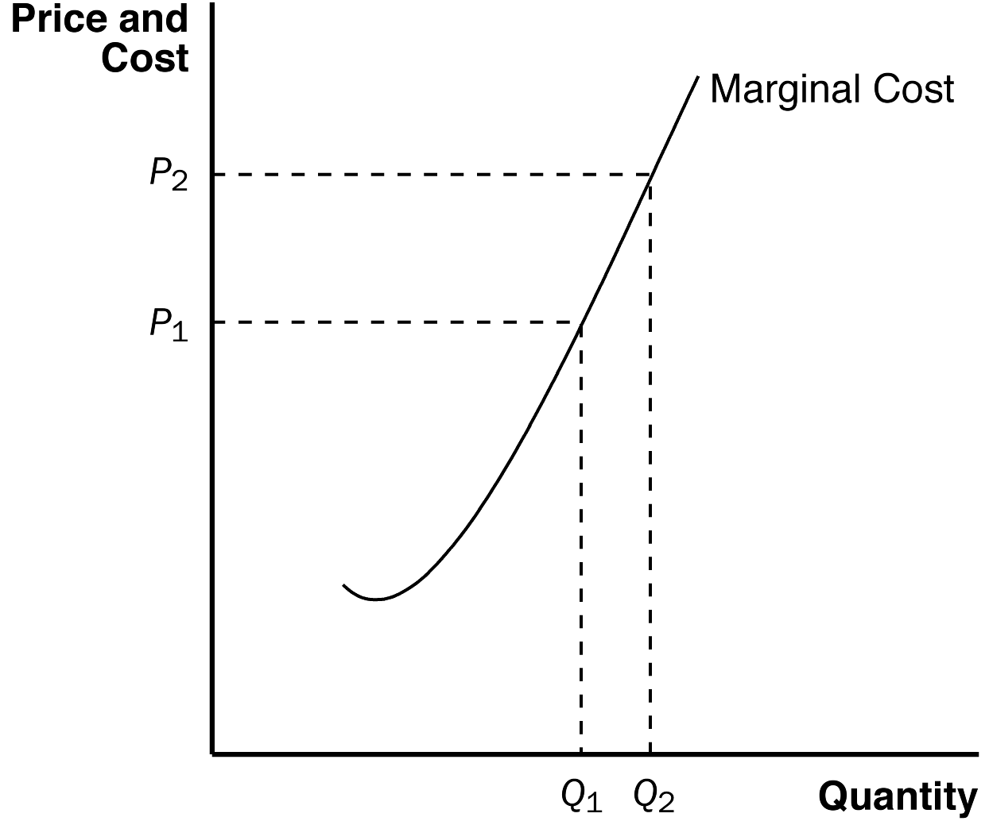

5. If the price in the market were to change to P₂, the firm would set its new level of output by equating marginal revenue and marginal cost.

6. Because the firm's marginal cost curve determines how much the firm is willing to supply at any price, it is the competitive firm's supply curve.

C. The Firm's Short-Run Decision to Shut Down

1. In certain circumstances, a firm will decide to shut down and produce zero output.

2. There is a difference between a temporary shutdown of a firm and an exit from the market.

a. A shutdown refers to a short-run decision not to produce anything during a specific period of time because of current market conditions.

b. Exit refers to a long-run decision to leave the market.

c. One important difference is that, when a firm shuts down temporarily, it still must pay fixed costs. If a firm exits the industry in the long run, it has no costs.

3. If a firm shuts down, it will earn no revenue and will have only fixed costs (no variable costs).

4. Therefore, a firm will shut down if the revenue that it would earn from producing is less than its variable costs of production:

Shut down if TR < VC.

5. Because TR = P x Q and VC = AVC x Q, we can rewrite this condition as:

Shut down if P < AVC.

6. We now can tell exactly what the firm will do to maximize profit (or minimize loss).

a. If the price is less than average variable cost, the firm will produce no output.

b. If the price is above average variable cost, the firm will produce the level of output where marginal revenue (price) is equal to marginal cost.

If: | The Firm Will:
P ≥ AVC | Produce output level where MR = MC
P < AVC | Shut down and produce zero output

7. Therefore, the competitive firm's short-run supply curve is the portion of its marginal revenue curve that lies above average variable cost.

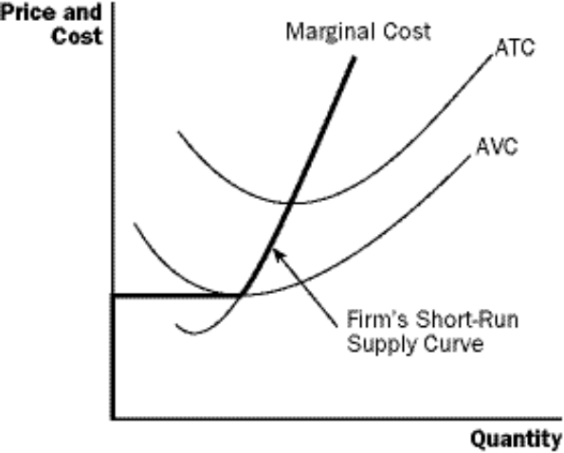
Figure 3

8. Spilt Milk and Other Sunk Costs

a. Definition of sunk cost: a cost that has been committed and cannot be recovered.

b. Once a cost is sunk, it is no longer an opportunity cost.

c. Because nothing can be done about sunk costs, you should ignore them when making decisions.

9. Case Study: Near-Empty Restaurants and Off-Season Miniature Golf

a. In making a decision of whether to open for lunch, a restaurant owner must weigh revenue with variable costs. (Much of the cost of running a restaurant is somewhat fixed.)

b. The same criteria would apply to a decision of whether a miniature golf course in a summer resort community should stay open during other seasons. The course should only be open if revenue exceeds variable costs.

D. The Firm's Long-Run Decision to Exit or Enter a Market

1. If a firm exits the market, it will earn no revenue, but it will have no costs as well.

2. Therefore, a firm will exit if the revenue that it would earn from producing is less than its total costs:

Exit if TR < TC.

3. Because TR = P x Q and TC = ATC x Q, we can rewrite this condition as:

Exit if P < ATC.

4. A firm will enter an industry when there is profit potential, so this must mean that a firm will enter if revenues will exceed costs:

Enter if P > ATC.
Figure 4

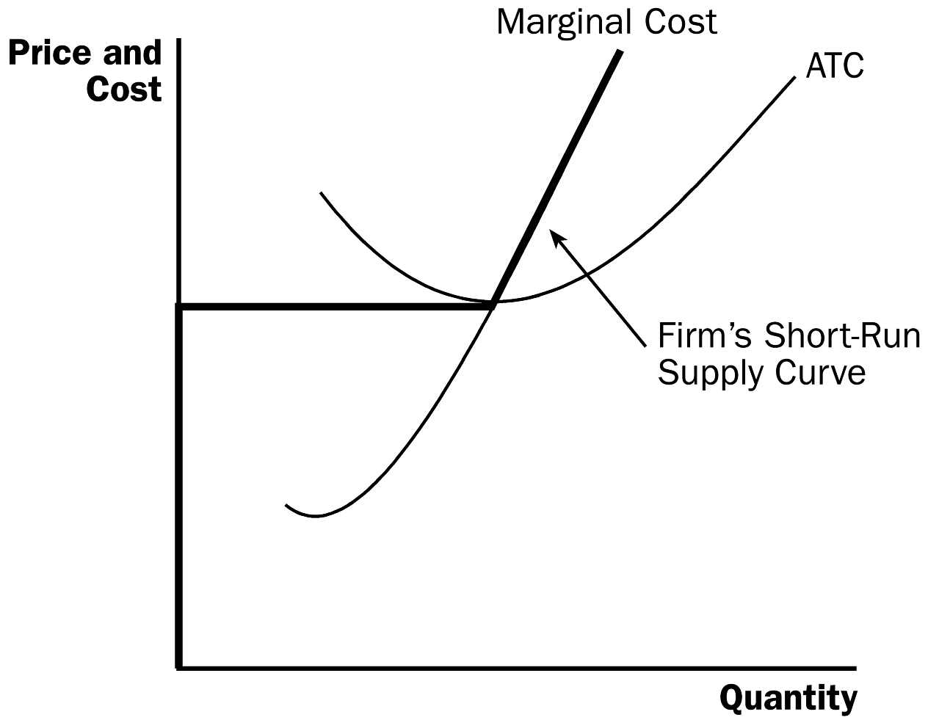

5. Because, in the long run, a firm will remain in a market only if P ≥ ATC, the firm's long-run supply curve will be its marginal cost curve above ATC.

If: | The Firm Will:
P > ATC | Enter because economic profits are earned
P = ATC | Not enter or exit because economic profits are zero
P < ATC | Exit because economic losses are incurred

E. Measuring Profit in Our Graph for the Competitive Firm

1. Recall that Profit = TR –TC.

2. Because TR = P x Q and TC = ATC x Q, we can rewrite this equation:

Profit = (P – ATC) x Q.

Figure 5

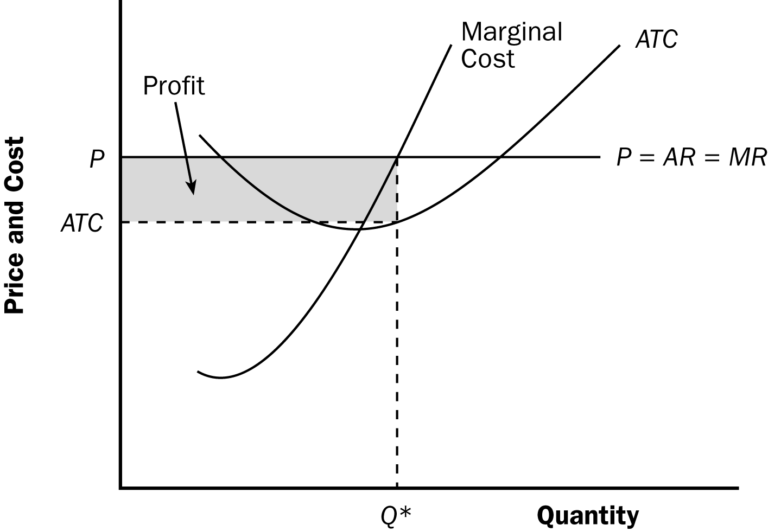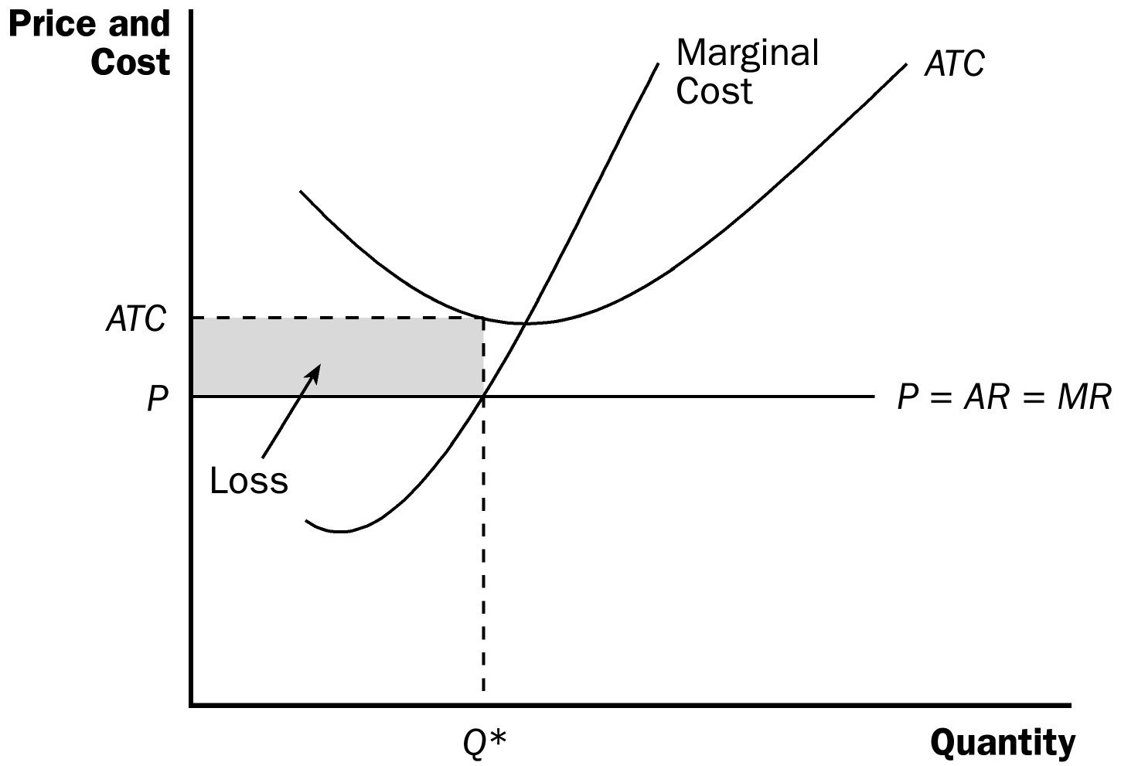

3. Using this equation, we can measure the amount of profit (or loss) at the firm's profit-maximizing level of output (or loss-minimizing level of output).
Students always want to use the point of minimum average total cost when finding profit on the graph. Remind them to always find the average total cost of the profit-maximizing level of output.

Keep reminding students that economic profits and losses are different from accounting profits and losses. Point out that economic cost includes the cost of all resources, including a “normal return or profit” to compensate the firm’s owner for the risks and other efforts put into the business.

III. The Supply Curve in a Competitive Market

A. The Short Run: Market Supply with a Fixed Number of Firms
Figure 6

1. Example: a market with 1,000 identical firms.

2. Each firm's short-run supply curve is its marginal cost curve above average variable cost.

3. To get the market supply curve, we add the quantity supplied by each firm in the market at every given price.

B. The Long Run: Market Supply with Entry and Exit
Figure 7

1. If firms in a market are earning profit, this will attract new firms.

a. The supply of the product will increase (the supply curve will shift to the right).

b. The price of the product will fall and profit will decline.

2. If firms in an industry are incurring losses, firms will exit.

a. The supply of the product will decrease (the supply curve will shift to the left).

b. The price of the product will rise and losses will decline.

3. At the end of this process of entry or exit, firms that remain in the market must be earning zero economic profit.

4. Because Profit = TR –TC, profit will only be zero when:

TR = TC.

5. Because TR = P × Q and TC = ATC × Q, we can rewrite this as:

P = ATC.

6. Therefore, the process of entry or exit ends only when price and average total cost become equal.

7. This implies that the long-run equilibrium of a competitive market must have firms operating at their efficient scale.

C. Why Do Competitive Firms Stay in Business If They Make Zero Profit?

1. Profit is equal to total revenue minus total cost.

2. To an economist, total cost includes all of the opportunity costs of the firm.

3. When a firm is earning zero profit, this must mean that the firm's revenues are compensating the firm's owners for their opportunity costs.

D. A Shift in Demand in the Short Run and Long Run

1. Assume that the market begins in long-run equilibrium. This means that firms are earning zero profit and price equals the minimum of average total cost.

2. If the demand for the product increases, this will lead to an increase in the price of the good.

3. Firms will respond to the increase in price by producing more in the short run.

4. Because price is now greater than average total cost, firms are earning profit.

Figure 8

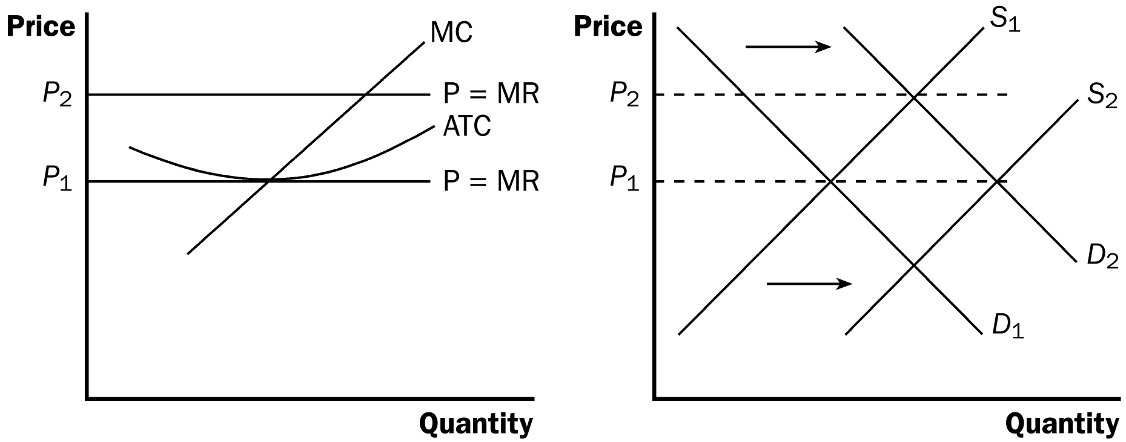

5. The profit will attract new firms into the market, shifting the supply curve to the right.

6. This will lower price until it falls back to the minimum of average total cost and firms are once again earning zero economic profit.

After going through the effects of an increase in demand, ask students to work through the effects of a decrease in demand. Make sure that they can see that firms would exit the market because of economic losses.

E. Why the Long-Run Supply Curve Might Slope Upward

1. Because we assumed that all potential entrants faced the same costs as existing firms, average total cost of each firm was unaffected by the entry of new firms into the market.

2. In this situation, the long-run supply of the market will be a horizontal line at minimum average total cost.

3. However, there are two possible reasons why this may not be the case.

a. If a resource is limited in quantity, entry of firms will increase the price of this resource, raising the average total cost of production.

b. If firms have different costs, then it is likely that those with the lowest costs will enter the market first. If the demand for the product then increases, the firms that would enter will likely have higher costs than those firms already in the market.

4. In this situation, the long-run supply curve of the market will be upward sloping.

No matter what the shape of the long-run supply curve, an increase in demand will always lead to a rise in the price in the short run and a decrease in demand will always lead to a drop in price in the short run.

5. In either case, the long-run supply curve of a market is generally more elastic than the short-run supply curve of the market (because firms can enter or exit in the long run).

SOLUTIONS TO TEXT PROBLEMS:

Quick Quizzes

1. When a competitive firm doubles the amount it sells, the price remains the same, so its total revenue doubles.

2. A profit-maximizing competitive firm sets price equal to its marginal cost. If price were above marginal cost, the firm could increase profits by increasing output, while if price were below marginal cost, the firm could increase profits by decreasing output.

A profit-maximizing competitive firm decides to shut down in the short run when price is less than average variable cost. In the long run, a firm will exit a market when price is less than average total cost.

3. In the long run, with free entry and exit, the price in the market is equal to both a firm’s marginal cost and its average total cost, as Figure 1 shows. The firm chooses its quantity so that marginal cost equals price; doing so ensures that the firm is maximizing its profit. In the long run, entry into and exit from the market drive the price of the good to the minimum point on the average-total-cost curve.

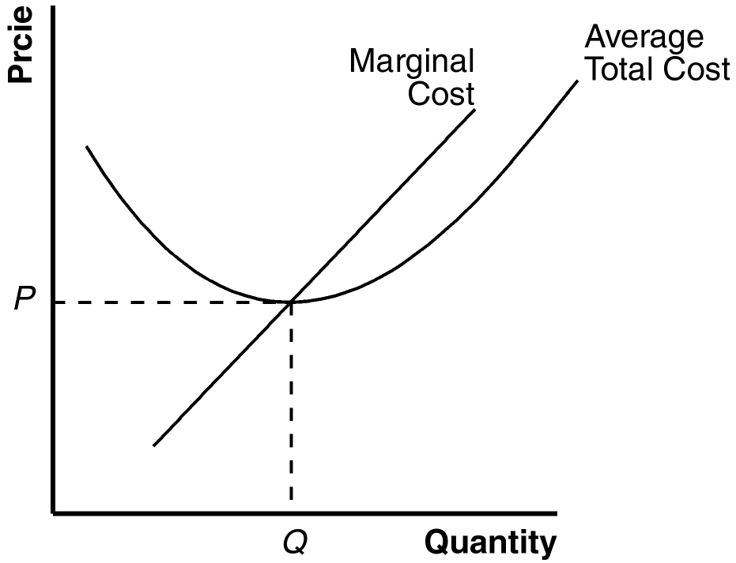

Figure 1

Questions for Review

1. The main characteristics of a competitive firm are: (1) there are many buyers and many sellers in the market; (2) the goods offered by the various sellers are largely the same; and (3) usually firms can freely enter or exit the market.

2. A firm’s total revenue equals its price multiplied by the quantity of units it sells. Profit is the difference between total revenue and total cost. Firms are assumed to maximize profit.

3. Figure 2 shows the cost curves for a typical firm. A competitive firm chooses the level of output that maximizes profit where marginal cost equals price (Q*), as long as price exceeds average variable cost at that point (in the short run), or exceeds average total cost (in the long run). Total revenue can be measured by the rectangular area with a height of P* and a base of Q*. Total cost can be measured by the rectangular area with a height of ATC’ and a base of Q*.

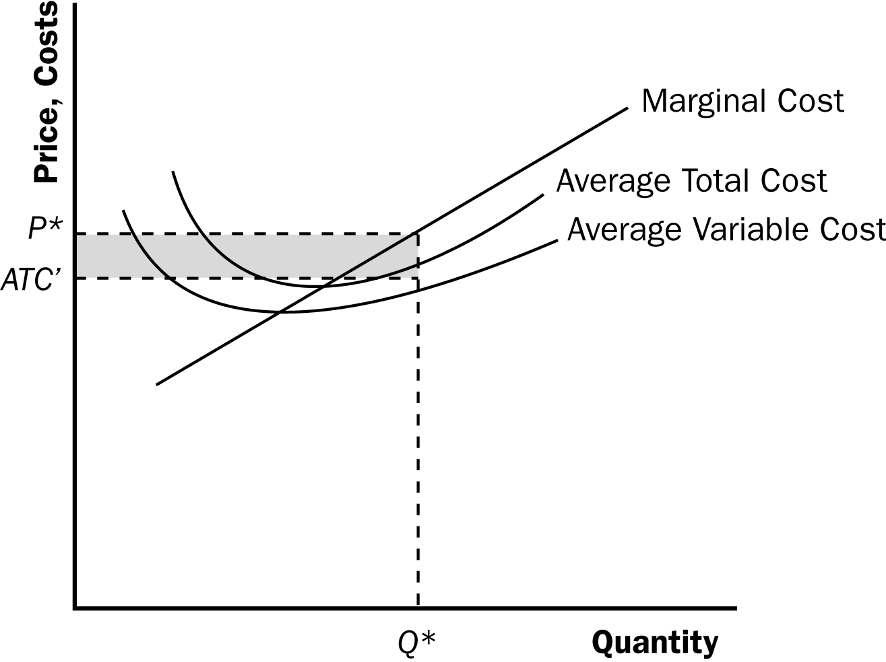

Figure 2

4. A firm will shut down temporarily if the revenue it would get from producing is lower than the variable costs of production. This occurs if price is less than average variable cost.

5. A firm will exit a market if the revenue it would get from remaining in business is less than its total cost. This occurs if price is less than average total cost.

6. A competitive firm's price equals its marginal cost in both the short run and the long run. In both the short run and the long run, price equals marginal revenue. The firm should increase output as long as marginal revenue exceeds marginal cost, and reduce output if marginal revenue is less than marginal cost. Profits are always maximized when marginal revenue equals marginal cost.

7. The competitive firm's price must equal the minimum of its average total cost only in the long run. In the short run, price may be greater than average total cost (in which case the firm is earning a profit), price may be less than average total cost (in which case the firm is incurring a loss), or price may be equal to average total cost (in which case the firm is breaking even). In the long run, if firms are earning profits, other firms will enter the industry, which will lower the price of the good. In the long run, if firms are incurring losses, they will exit the industry, which will raise the price of the good. Entry or exit continues until firms are making neither profits nor losses. At that point, price equals average total cost.

8. Market supply curves are typically more elastic in the long run than in the short run. In a competitive market, because entry or exit occurs until price equals average total cost, quantity supplied is more responsive to changes in price in the long run.

Quick Check Multiple Choice

1. c

2. b

3. d

4. a

5. d

6. c

Problems and Applications

1. a. As shown in Figure 3, the typical firm's initial marginal-cost curve is MC₁ and its average-total-cost curve is ATC₁. In the initial equilibrium, the market supply curve, S₁, intersects the demand curve at price P₁, which is equal to the minimum average total cost of the typical firm. Thus, the typical firm earns no economic profit. The rise in the price of crude oil increases production costs for individual firms (from MC₁ to MC₂ and from ATC₁ to ATC₂) and thus shifts the market supply curve to the left, to S₂.

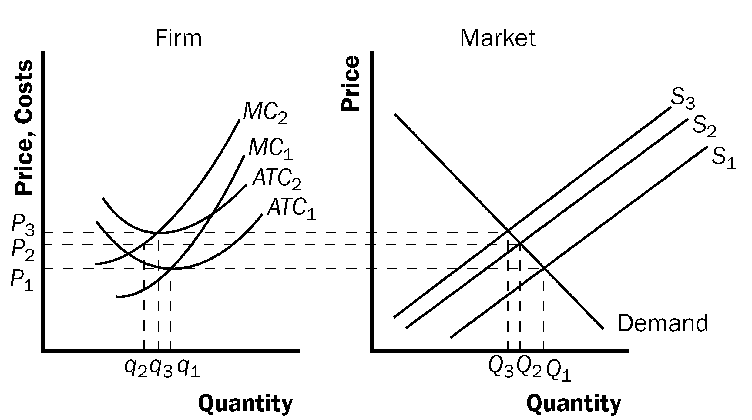

Figure 3

b. When the market supply curve shifts left to S₂, the equilibrium price rises from P₁ to P₂, but the price does not increase by as much as the increase in marginal cost for the firm. As a result, price is less than average total cost for the firm, so profits are negative.

In the long run, the negative profits lead some firms to exit the market. As they do so, the market supply curve shifts to the left. This continues until the price rises to equal the minimum point on the firm's average-total-cost curve. The long-run equilibrium occurs with supply curve S₃, equilibrium price P₃, total market output Q₃, and firm's output q₃. Thus, in the long run, profits are zero again and there are fewer firms in the market.

2. Once you have ordered the dinner, its cost is sunk, so it does not represent an opportunity cost. As a result, the cost of the dinner should not influence your decision about whether to finish it.

3. Bob' total variable cost is his total cost each day less his fixed cost ($280 - $30 = $250). His average variable cost is his total variable cost each day divided by the number of lawns he mows each day ($250/10 = $25). Because his average variable cost is less than his price, he will not shut down in the short run. Bob's average total cost is his total cost each day divided by the number of lawns he mows each day ($280/10 = $28). Because his average total cost is greater than his price, he will exit the industry in the long run.

4. Here is the table showing costs, revenues, and profits:

Quantity | Total Cost | Marginal Cost | Total Revenue | Marginal Revenue | Profit
0 | $8 | --- | $0 | --- | $-8
1 | 9 | $1 | 8 | $8 | -1
2 | 10 | 1 | 16 | 8 | 6
3 | 11 | 1 | 24 | 8 | 13
4 | 13 | 2 | 32 | 8 | 19
5 | 19 | 6 | 40 | 8 | 21
6 | 27 | 8 | 48 | 8 | 21
7 | 37 | 10 | 56 | 8 | 19

a. The firm should produce five or six units to maximize profit.

b. Marginal revenue and marginal cost are graphed in Figure 4. The curves cross at a quantity between five and six units, yielding the same answer as in Part (a).

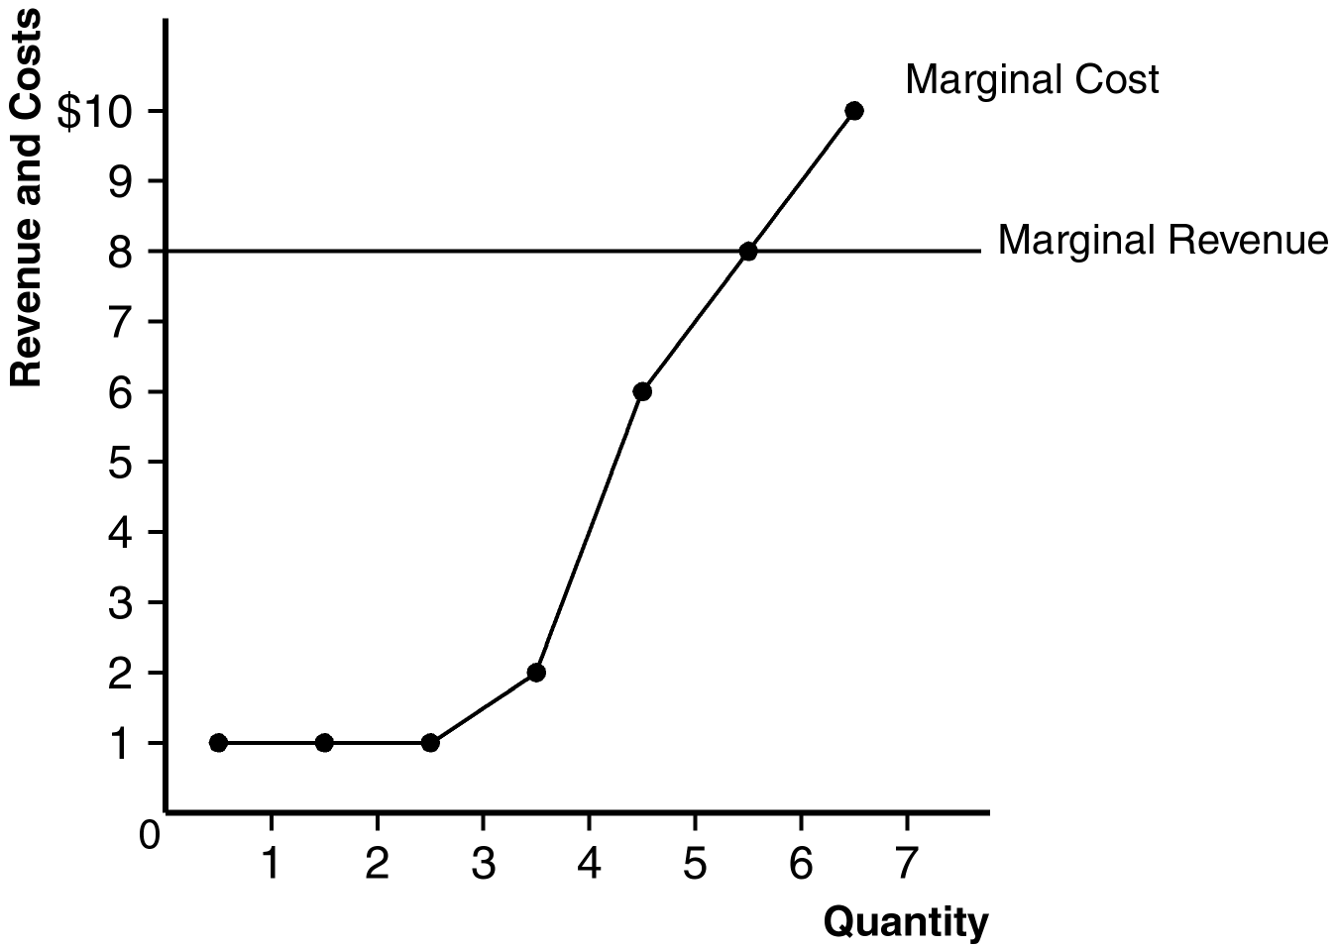

Figure 4

c. This industry is competitive because marginal revenue is the same for each quantity. The industry is not in long-run equilibrium, because profit is not equal to zero.

5. a. Costs are shown in the following table:

Q | TFC | TVC | AFC | AVC | ATC | MC
0 | $100 | $0 | ---- | ---- | ---- | ----
1 | 100 | 50 | $100 | $50 | 150 | 50
2 | 100 | 70 | 50 | 35 | 85 | 20
3 | 100 | 90 | 33.3 | 30 | 63.3 | 20
4 | 100 | 140 | 25 | 35 | 60 | 50
5 | 100 | 200 | 20 | 40 | 60 | 60
6 | 100 | 360 | 16.7 | 60 | 76.7 | 160

b. If the price is $50, the firm will minimize its loss by producing 4 units, where price is equal to marginal cost. When the firm produces 4 units, its total revenue is $200 ($50 x 4 = $200) and its total cost is $240 ($100 + $140). This would give the firm a loss of $40. If the firm shuts down, it will earn a loss equal to its fixed cost ($100). The CEO did not make a wise decision.

c. If the firm produces 1 unit, its total revenue is $50 and its total cost is $150 ($100 + $50), so its loss will still be $100. This was also not the best decision. The firm could have reduced its loss by producing more units because the marginal costs of the second and third unit are lower than the price.

6. a. Figure 5 shows the curves of a typical firm in the industry, with average total cost ATC₁, marginal cost MC₁, and marginal revenue equal to price P₁. The long-run-supply curve is the marginal cost curve above the minimum point of ATC₁.

b. The new process reduces Hi-Tech’s marginal cost to MC₂ and its average total cost to ATC₂, but the price remains at P₁ because other firms cannot use the new process. Thus Hi-Tech produces Q₂ units and earns positive profits.

c. When the patent expires and other firms are free to use the technology, all firms’ average-total-cost curves decline to ATC₂, so the market price falls to P₃ and firms earn zero profit.

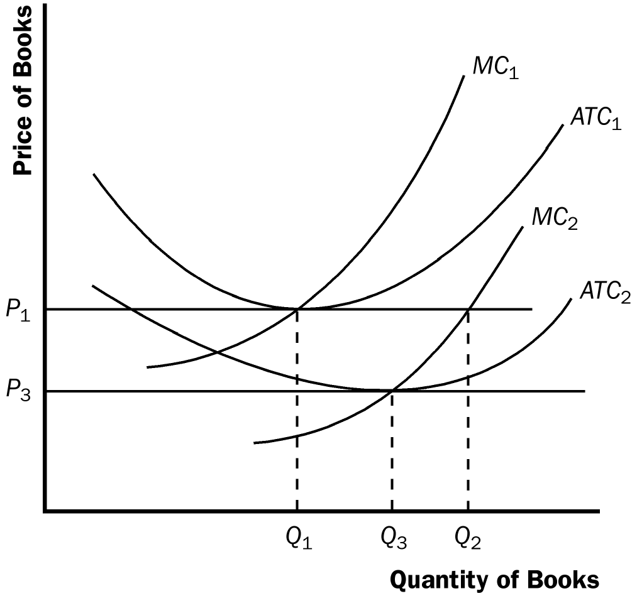

Figure 5

7. Since the firm operates in a perfectly competitive market, its price is equal to its marginal revenue of $10. This means that average revenue is also $10 and 50 units were sold.

8. a. Profit is equal to (P – ATC) × Q. Price is equal to AR. Therefore, profit is ($10 – $8) × 100 = $200.

b. For firms in perfect competition, marginal revenue and average revenue are equal. Since profit maximization also implies that marginal revenue is equal to marginal cost, marginal cost must be $10.

c. Average fixed cost is equal to AFC /Q which is $200/100 = $2. Since average variable cost is equal to average total cost minus average fixed cost, AVC = $8 − $2 = $6.

d. Since average total cost is less than marginal cost, average total cost must be rising. Therefore, the efficient scale must occur at an output level less than 100.

9. a. If firms are currently incurring losses, price must be less than average total cost. However, because firms in the industry are currently producing output, price must be greater than average variable cost. If firms are maximizing profits, price must be equal to marginal cost.

b. The present situation is depicted in Figure 6. The firm is currently producing q₁ units of output at a price of P₁.

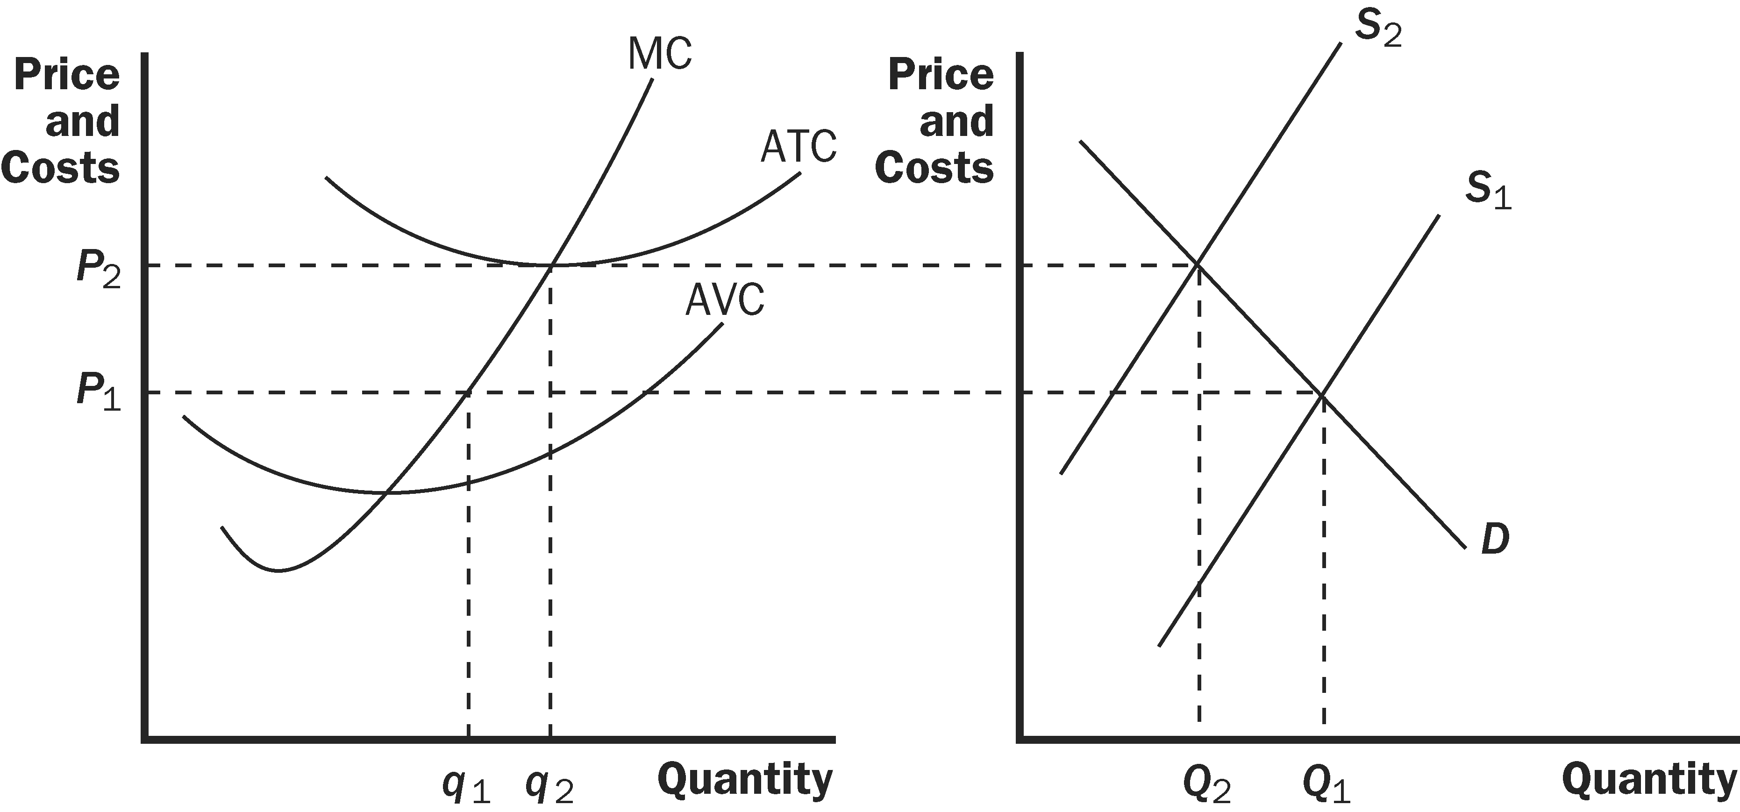

Figure 6

c. Figure 6 also shows how the market will adjust in the long run. Because firms are incurring losses, there will be exit in this industry. This means that the market supply curve will shift to the left, increasing the price of the product. As the price rises, the remaining firms will increase quantity supplied; marginal cost will increase. Exit will continue until price is equal to minimum average total cost. Average total cost will be lower in the long run than in the short run. The total quantity supplied in the market will fall.
10. a. The table below shows TC and ATC for a typical firm:

Q | TC | ATC
1 | 11 | 11
2 | 15 | 7.5
3 | 21 | 7
4 | 29 | 7.25
5 | 39 | 7.8
6 | 51 | 8.5

b. At a price of $11, quantity demanded is 200. With marginal revenue of $11, each firm will choose to produce 5 pies where their marginal cost is closest to the marginal revenue without exceeding marginal revenue. Therefore, there will be 40 firms (= 200/5). Each producer will earn total revenue of $55 ($11 × 5), total cost is $39, so profit is $16.

c. The market is not in long-run equilibrium because firms are earning positive economic profit. Firms will want to enter the market.

d. With free entry and exit, each producer will earn zero profit in the long run. Long-run equilibrium will occur when price is equal to minimum average total cost ($7). At that price, 600 pies are demanded. Each firm will only produce 3 pies (the quantity at which, MC is closest to MR without exceeding MR) meaning that there will be 200 pie producers in the market.

11. a. Figure 7 illustrates the situation in the U.S. textile market. With no international trade, the market is in long-run equilibrium. Supply intersects demand at quantity Q₁ and price $30, with a typical firm producing output q₁.

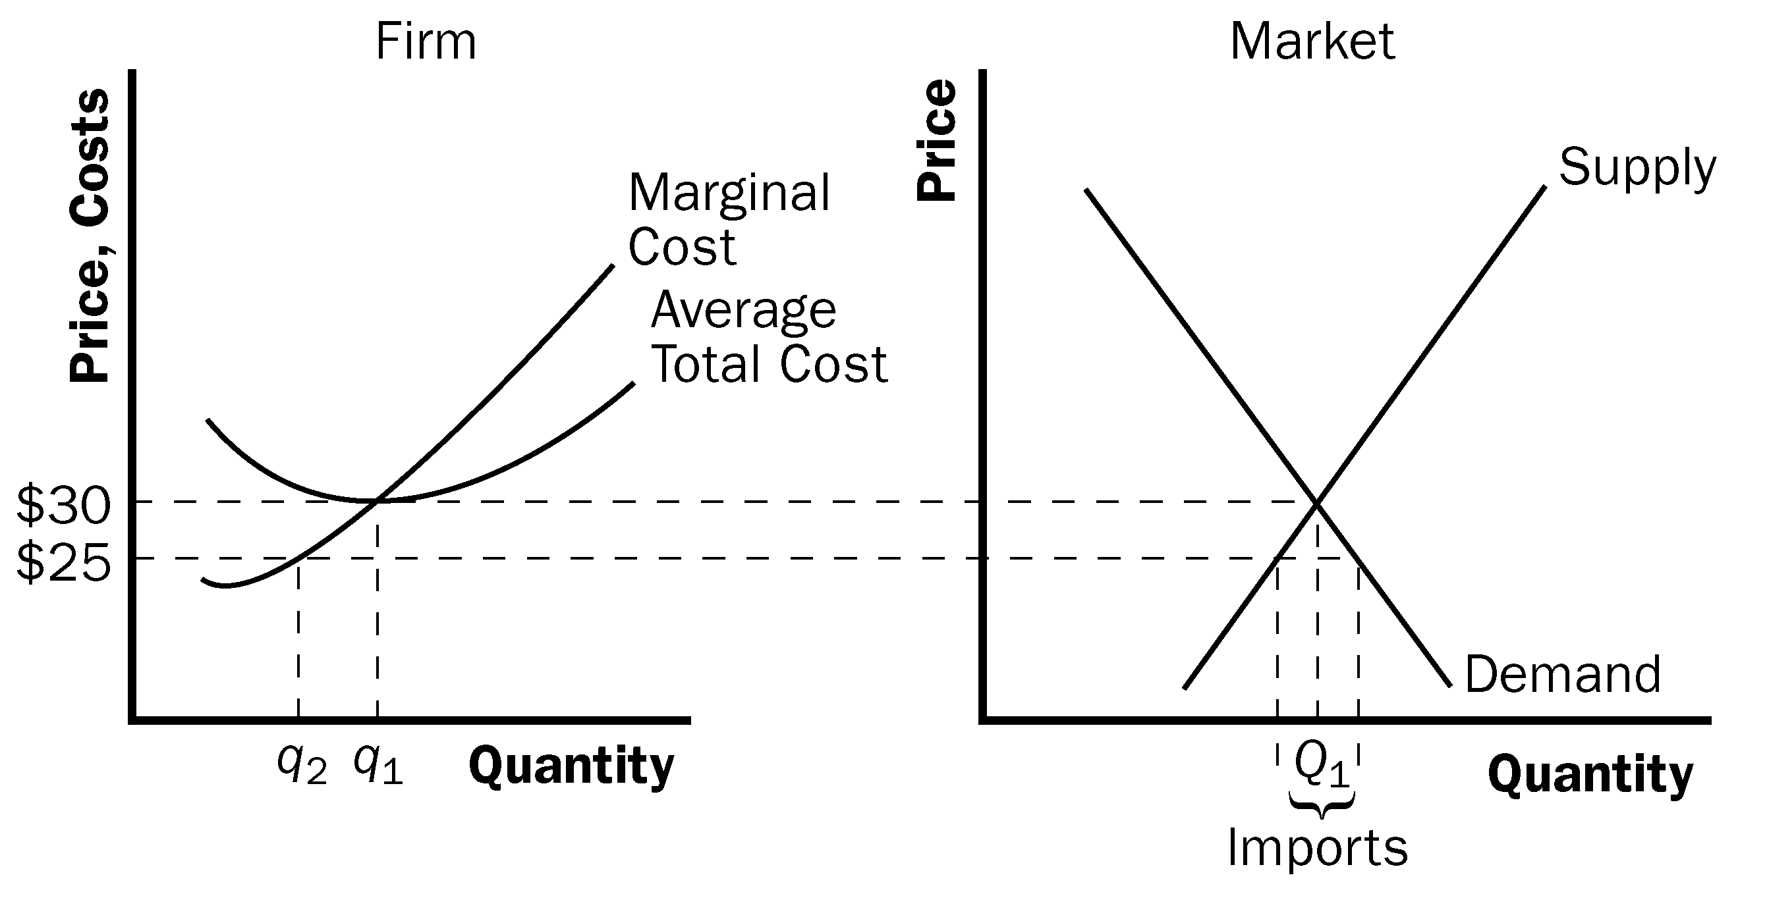

Figure 7

b. The effect of imports at $25 is that the market supply curve follows the old supply curve up to a price of $25, then becomes horizontal at that price. As a result, demand exceeds domestic supply, so the country imports textiles from other countries. The typical domestic firm now reduces its output from q₁ to q₂, incurring losses, because they were breaking even (profit equal to zero) in long-run equilibrium when the price was $30 and their average total cost has not decreased.

c. In the long run, domestic firms will be unable to compete with foreign firms because their costs are too high. All the domestic firms will exit the market and other countries will supply enough to satisfy the entire domestic demand.

12. a. The firms' variable cost (VC), total cost (TC), marginal cost (MC), and average total cost (ATC) are shown in the table below:

Quantity | VC | TC | MC | ATC
1 | 1 | 17 | 1 | 17
2 | 4 | 20 | 3 | 10
3 | 9 | 25 | 5 | 8.33
4 | 16 | 32 | 7 | 8
5 | 25 | 41 | 9 | 8.20
6 | 36 | 52 | 11 | 8.67

b. If the price is $10, each firm will produce 5 units. There are 100 firms in the industry, so there will be 5 × 100 = 500 units supplied in the market.

c. At a price of $10 and a quantity supplied of 5, each firm is earning a positive profit because price is greater than average total cost. Thus, entry will occur and the price will fall. As price falls, quantity demanded will rise in accordance with the law of demand. This entry will continue until price is equal to minimum average total cost, $8, and each firm is producing the quantity at which marginal revenue ($8) is equal to marginal cost (4 units if we assume units are not divisible). Therefore, the quantity supplied by each firm decreases.

d. Figure 8 shows the long-run market supply curve, which will be horizontal at minimum average total cost, $8. Each firm produces 4 units.

Market
Firm

Price
and
Costs
MC

ATC

S
P=$8
P=$8

q=4

Figure 8

